|  |  |  |  |  |  |
| --- | --- | --- | --- | --- | --- |
| Date | 9-Dec-22 | | | Tester Name | Mayuri Patel |
| Environment | Penfax - Test | | | Login used |  |
| Operating System | Windows | Version: | Update: | | |
| Software Used | Edge | Version: | Update: | | |
| Not Applicable | Version: | Update: | | |
| Release version | 22.4.1 | | | | |
| Title | External Transfer In | | | | |
| Test Type | Regression | | | | |
| Test Scenario | Process a Leave of Absence Repayment (cash) | | | | |
|  |  | | | | |
| Expected Results |  | | | | |
| Pass/Fail | Pass | | | JIRA# | N/A |

Describe your steps with screenshots:

1. Bring up the active member in PENFAX5. Open up a member.

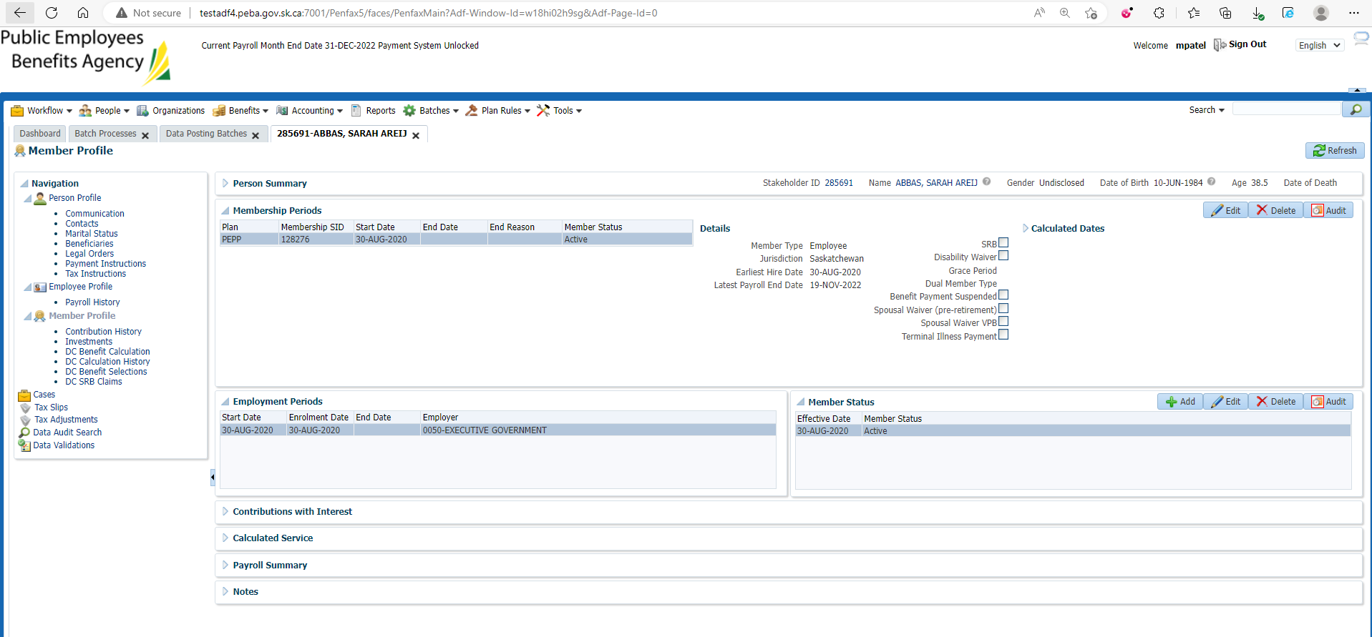

1. Go to Contribution History and click Add.

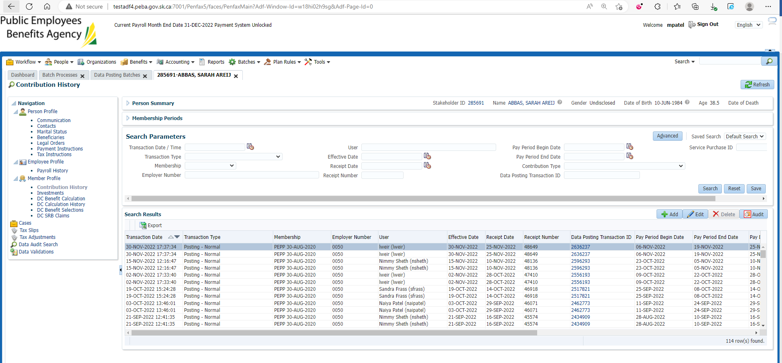

1. Under Membership the proper Membership period should default in.

Under Contribution Type Leave of Absence Repayment (Cash).

Enter Effective Date and Receipt Date more than 7 days in the past.

Under Amount, input an amount.

Hit Save.

Added Remittance

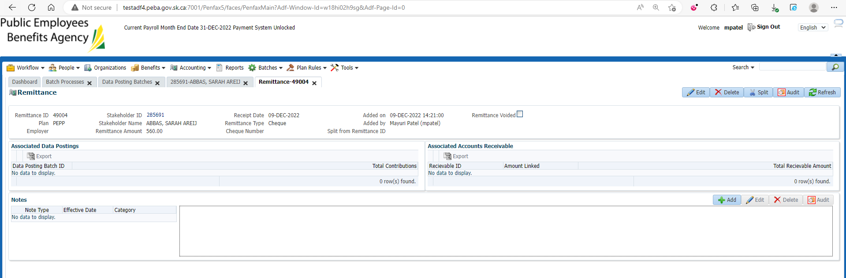

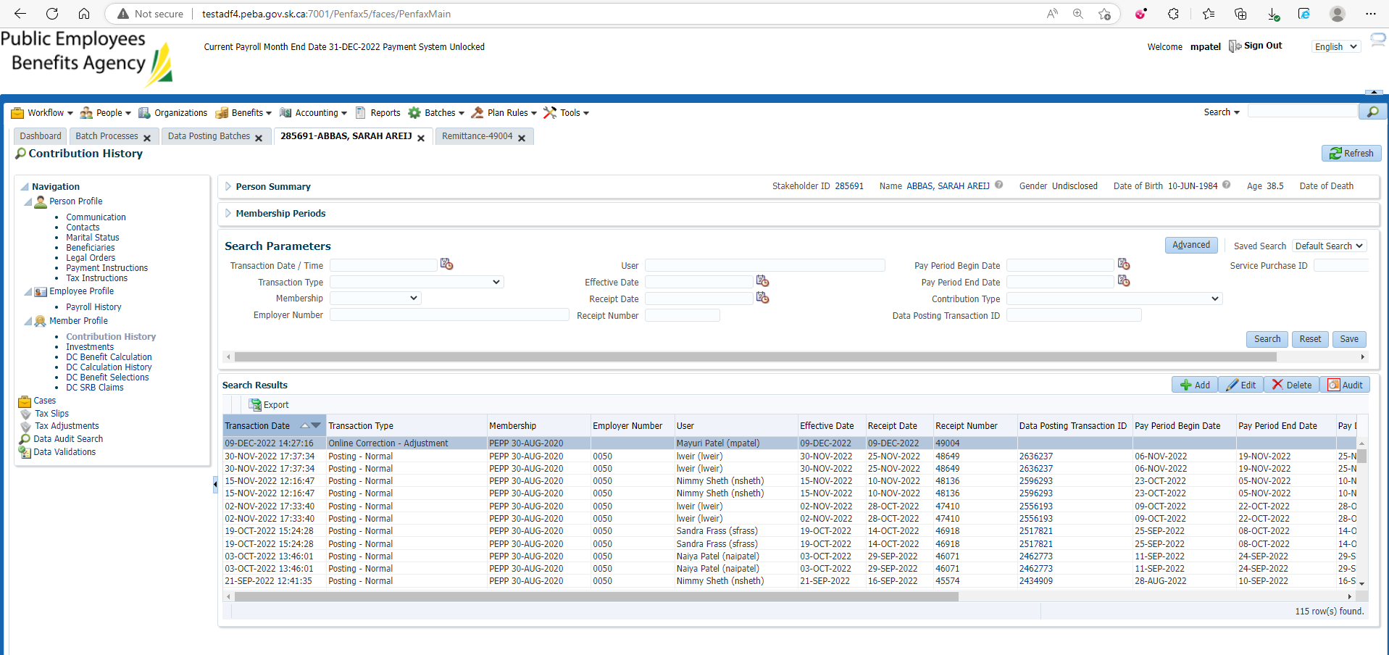

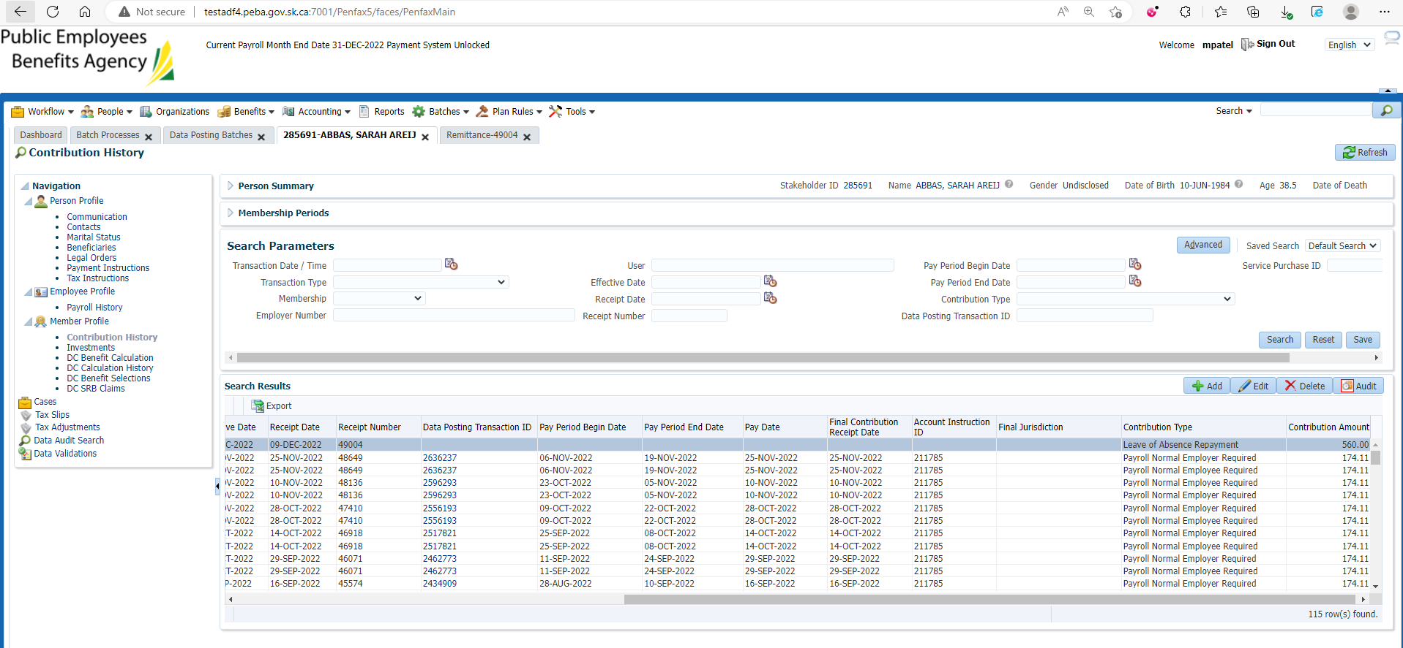

1. Wait for the next day, or process all the overnight batches to run.
2. Bring up the member again in PENFAX5. Go to the Investments Tab. Make sure the money shows up in the balance of the account. Also check the Deposit Allocation. Make sure the funds went into the correct account.

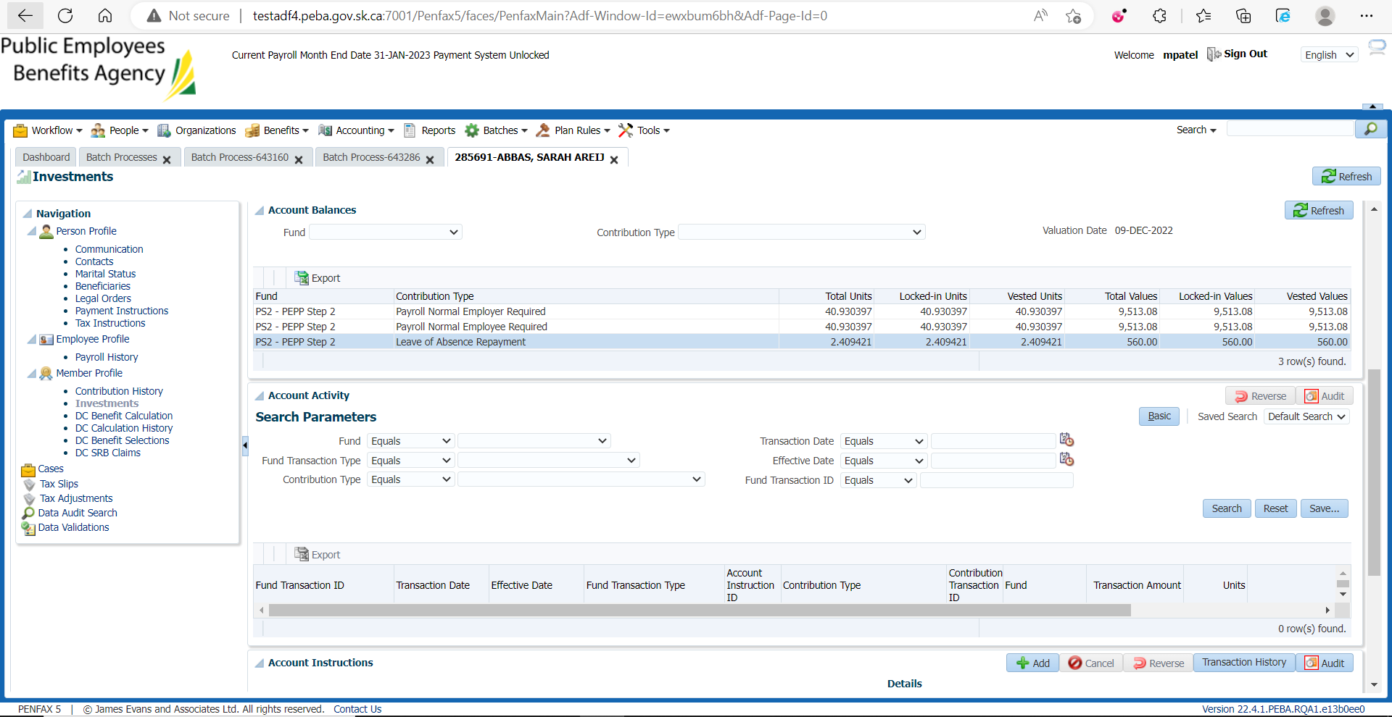

1. If you do a search under account activity it should show the transaction.

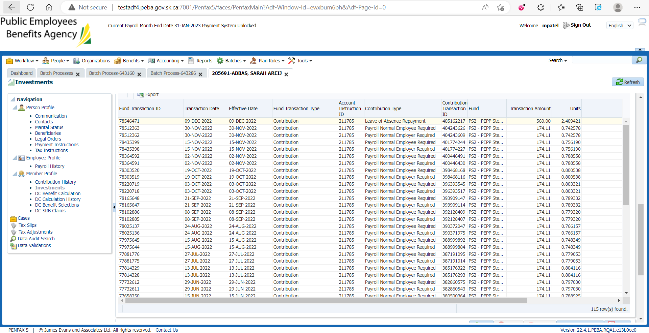

1. Go to the Communication tab. There should be a member deposit letter saved under Outbound Documents.

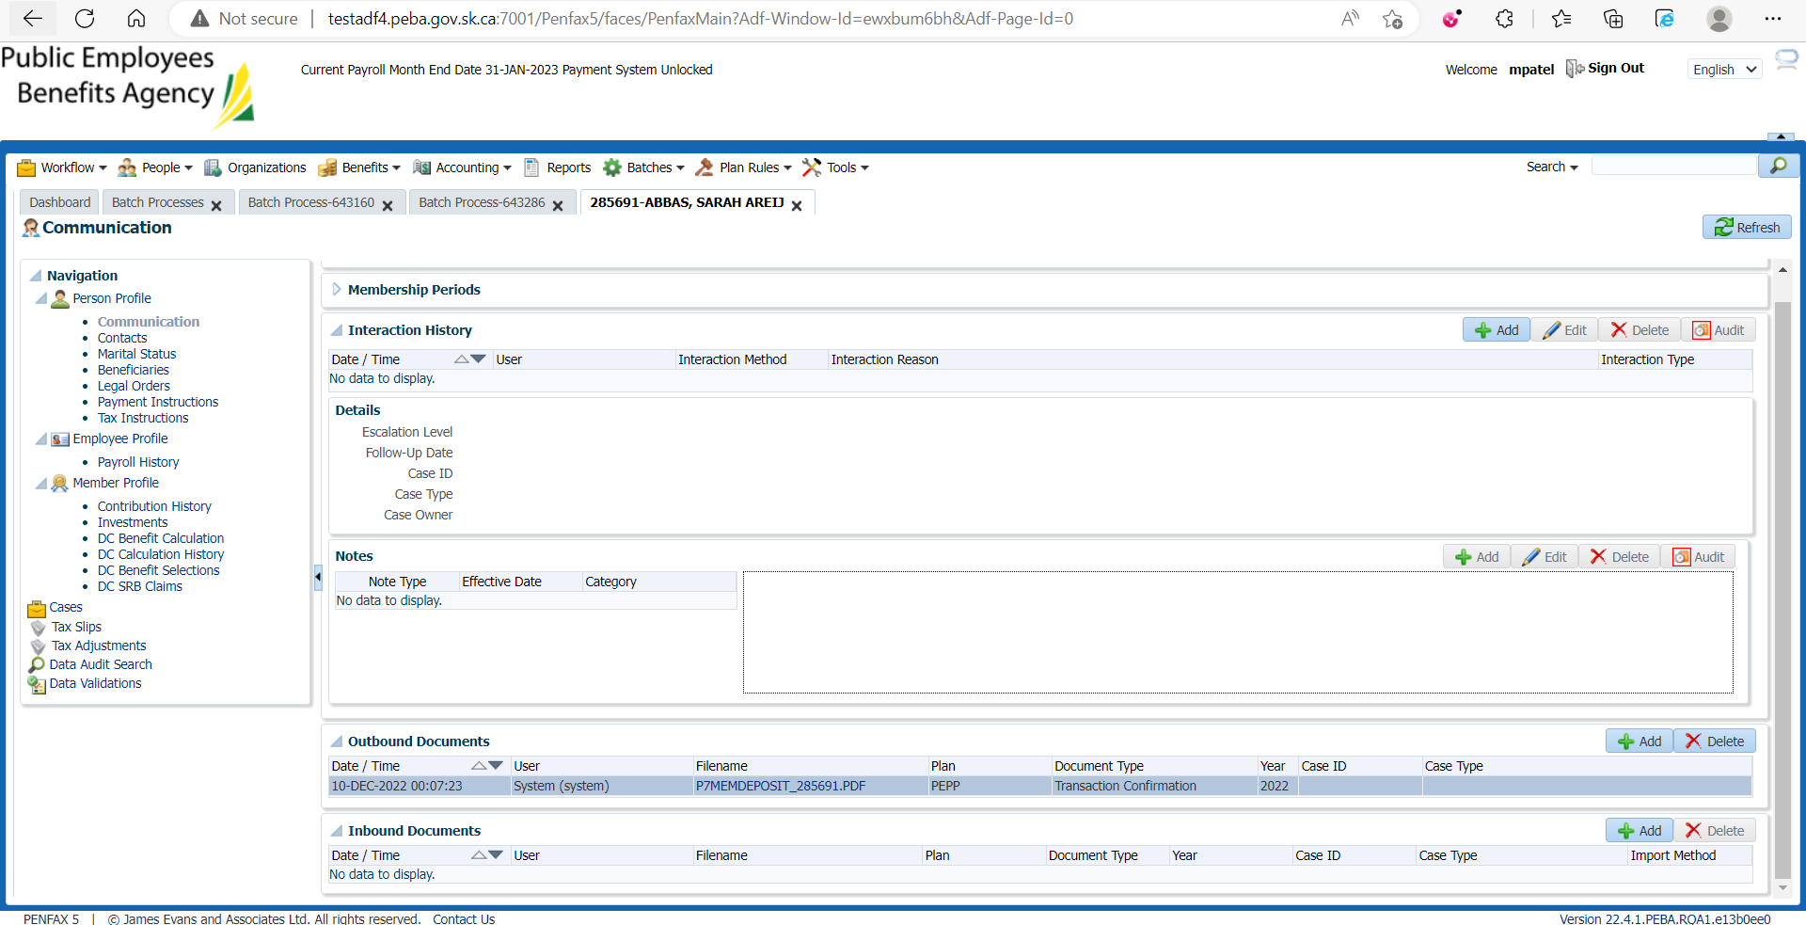

1. Go to Batches -> Batch Process -> Search for PEP Valuation Report.

On Section Two tab:

